Task on Terraform-5
1). Watch the Terraform-05 video.
Completed watching video
2). Execute the script shown in the video.
Let’s create s3 bucket
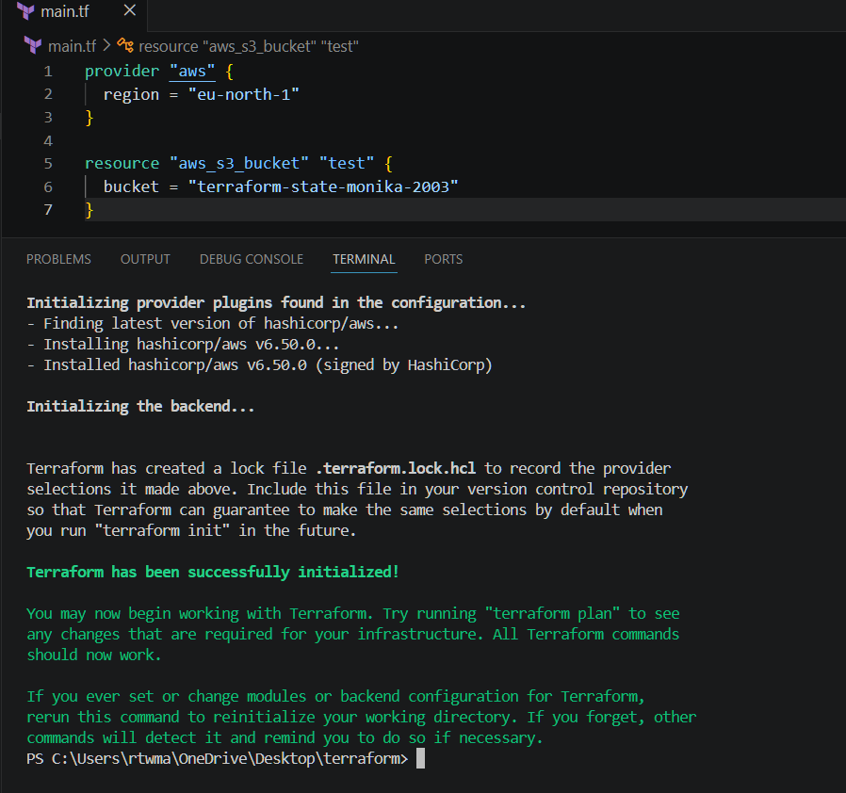
Terraform apply
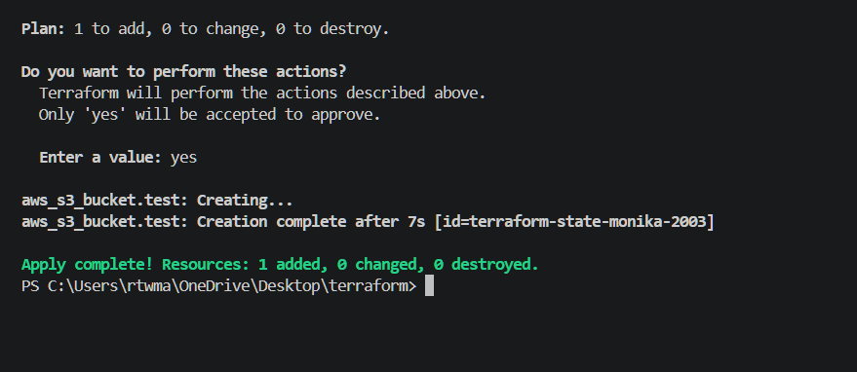
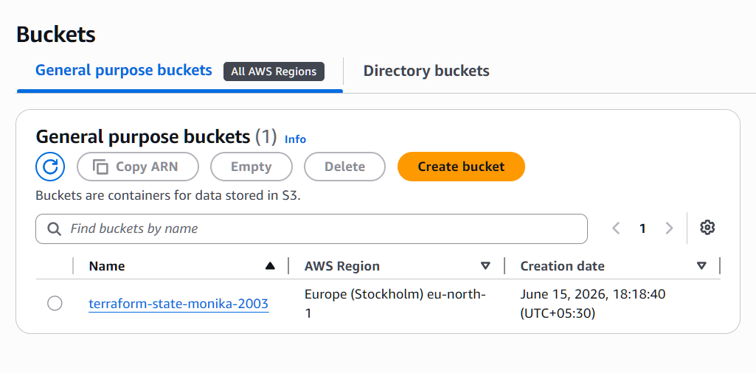
Provisioning
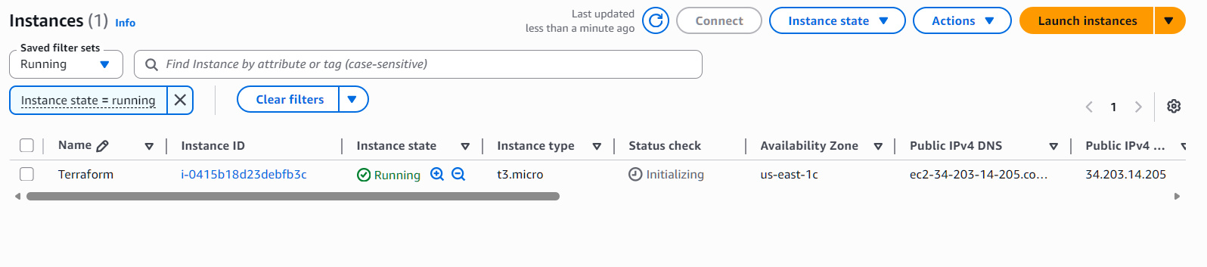
Statelock
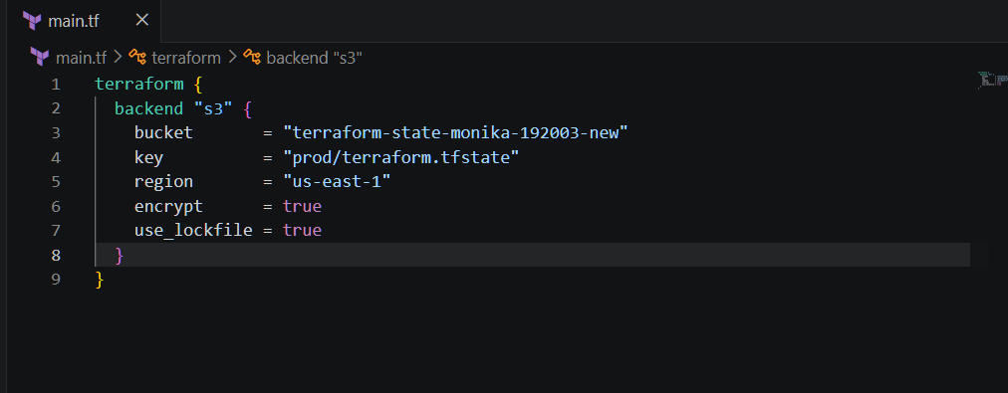
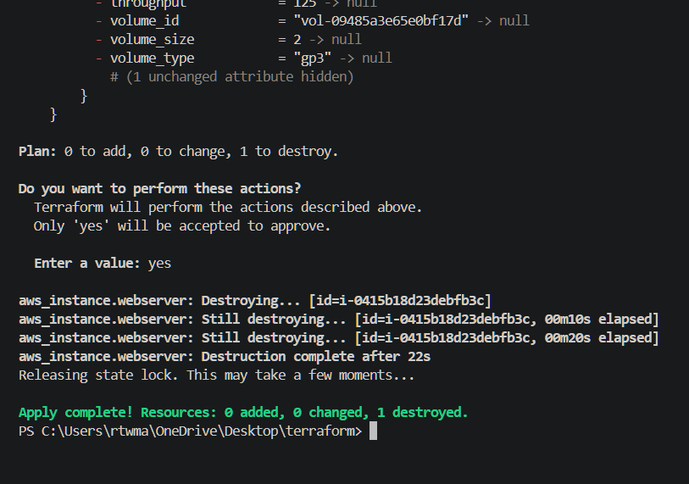
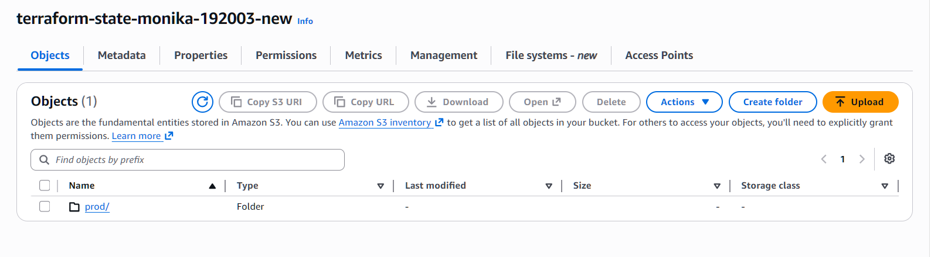

3). Create one EC2 instance with httpd installed using a Terraform script.
Remove-Item -Recurse -Force .terraform
Terraform init
Terraform plan
Terraform applt
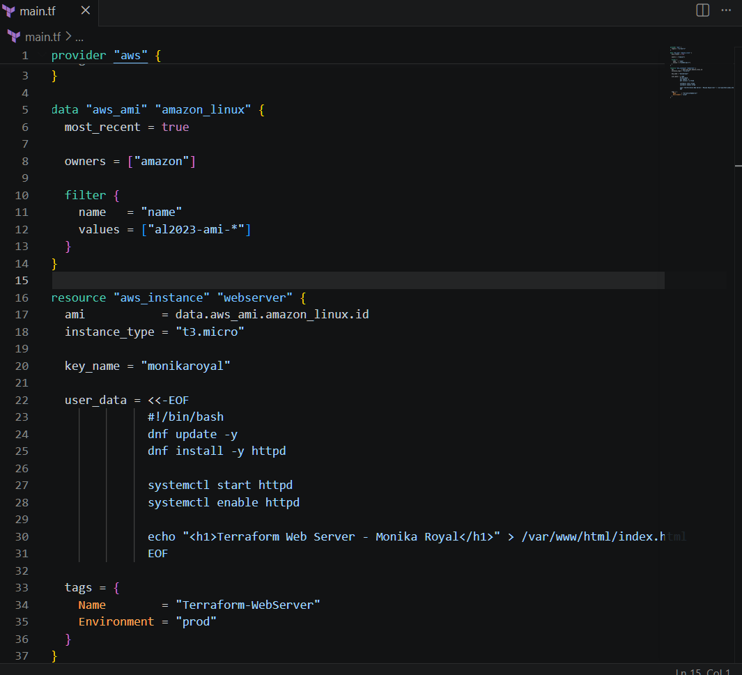
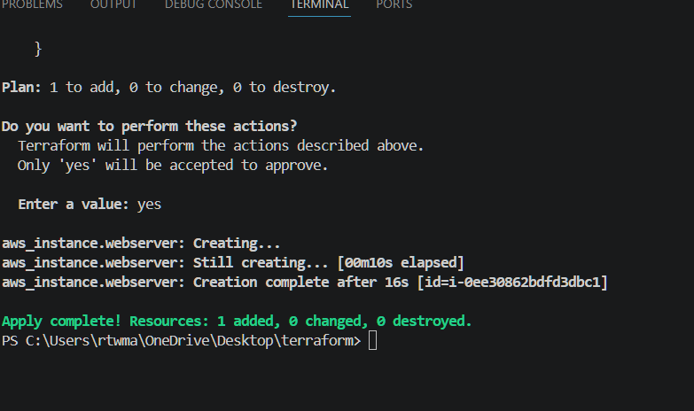
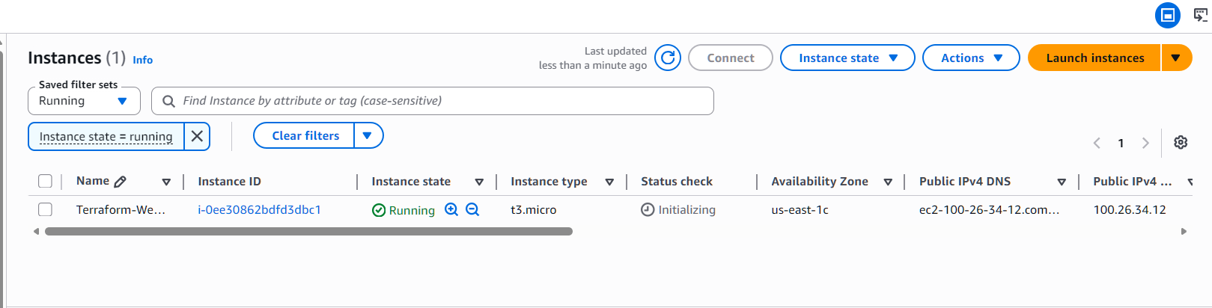
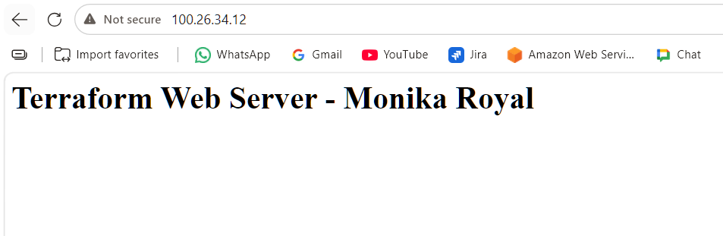
4). Set up S3 as backend for task 3.
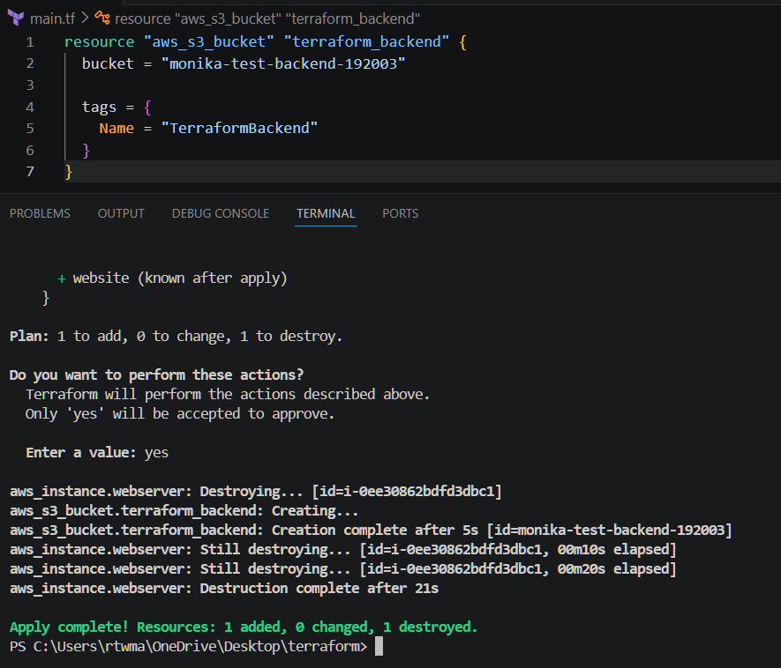
Bucket is created
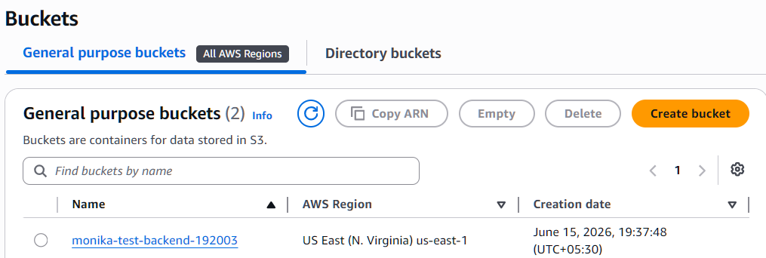
Now create a new file backend.tf
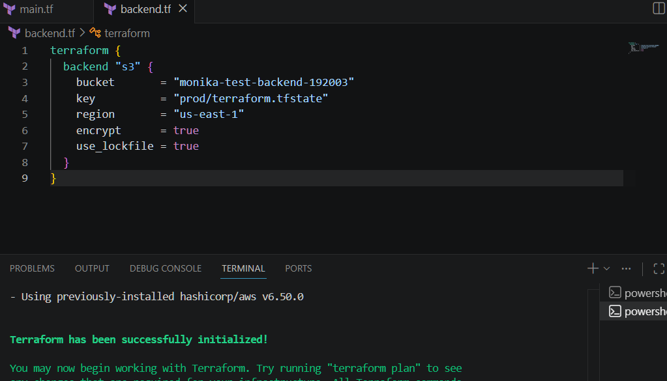
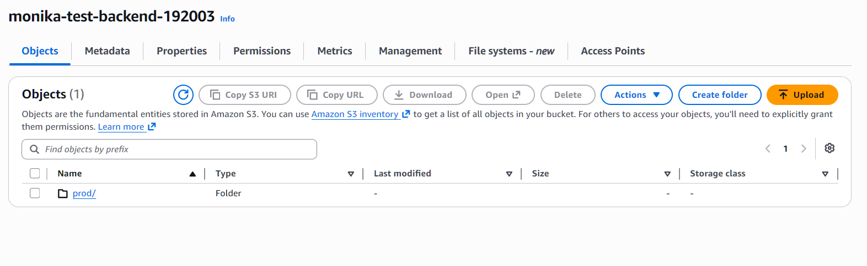
5). Set up DynamoDB locking for task 3.
Let’s create DynamoDB
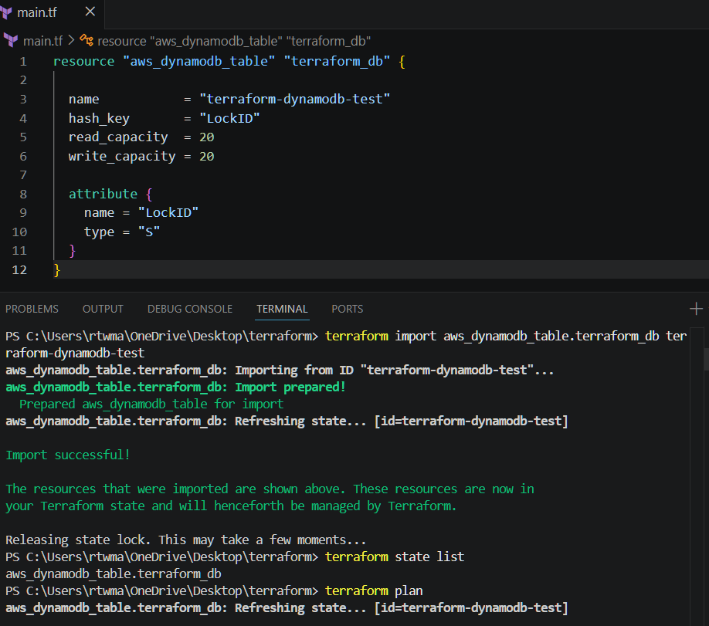
Dynamodb has been created successfully
